Nueces Delta Preserve

Teacher Workbook

Sixth Grade



Created August 2009

By: Lari Jo Wallace-Johnston

Updated December 2015 by: Josh Sendejar

**Table of Contents**

1. 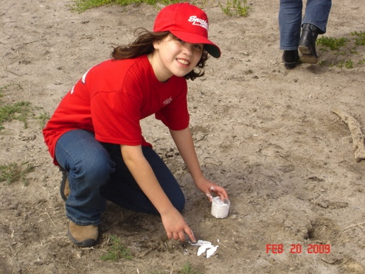Nueces River Delta
   1. Ecological History
   2. Eco-region
   3. Biotic Province
2. Vocabulary
3. Visiting the NDP
   1. Considerations for Planning your Trip
   2. Recommendations for Visiting NDP
   3. Standard Operating Procedures
4. Before you come
   1. Teacher Checklist
   2. In the Classroom
   3. Tips: Teacher to Teacher
5. Field Trip Activities
   1. General
   2. Habitat Hike
   3. Wetland Insects
   4. Healthy Pond
   5. Who’s Been to Rincon
   6. Particle Size
   7. Habitat Sketches
   8. Microscopic Wonders
6. Appendices
   1. Insect vs. Spider
   2. Recognition Of Common Orders Of Insects

CAREFULL PLANNING AND PREPARATION

CAN ASSURE YOUR FIELD TRIP IS A SUCCESSFUL ONE

Nueces River Delta

The Nueces River Delta is an estuary. It offers a variety of habitats to many different species. Estuaries can include coastal marshes, natural reefs, open bays, tidal flats, sea grass meadows, gulf beaches and barrier islands. Each provides a unique ecological area for organisms that have adapted to conditions found in these systems.

At the Nueces River Delta, water from four rivers, the East and West Nueces, Frio, and Atascosa, as well as springs, streams, and groundwater contribute to the inflow of fresh water to Nueces Bay. The Nueces Bay watershed includes an area of drains encompassing 16,800 square miles and carries an annual runoff of some 620,000 acre-feet.

The open ocean has an average salinity of 35ppt. The Gulf of Mexico has an average salinity of 32ppt. Due to evaporation, bay systems can have a wide range of salinities (0-100ppt). High salinities occur because salt does not evaporate with water. Low salinities occur when freshwater flows into the system. This can occur via river, creek, stream or rainfall.

The influx of fresh water from the rivers spurs productivity in the bay, bringing fresh water and nutrients to the system. Here, as in other estuaries, the difference in the densities between fresh and salt water cause the heavier salt water to flow upstream and the lighter fresh water to flow downstream producing a layered effect. Some of the saltwater mixes with the freshwater at a point called the interface.

The river carries not only water, but also sediments and nutrients to the delta. As the soil travels downstream, it is tumbled and eroded from large particles into smaller ones. As the water approaches the mouth of the river, the sediments are deposited to create new land masses. This new land is under continual change due to seasonal flooding that causes erosion and re-deposition. This physical weathering produces nutrient-rich habitats for different species of organisms to find a niche.

Estuaries, such as the Nueces River Delta, are unique ecosystems because they provide variety in physical and chemical conditions. Due to the varying degrees of salinity, estuaries provide several diverse habitats for a variety of organisms that have adapted to these unique factors in the ecosystem.

**Gulf Coast Prairies and Marshes**

The Gulf Coast Prairies and Marshes occupy approximately 9,500,000 acres. This eco-region is a nearly level, slowly drained plain less than 150 feet in elevation, dissected by streams and rivers flowing into the bays. The region includes the barrier islands lining the coast which protect the shoreline from erosion. Rainfall varies from 20 to 50 inches per year distributed fairly uniformly throughout the year.

Surficial and windblown sands and dunes characterize this region's soils. Soils on the Gulf Coast Prairies and Marshes are sandy loams, and clays. Sandy loams predominate, with clays occurring in river bottoms.

Vegetation is primarily grassland with some mottes, salt marshes and areas of thornscrub. The climax vegetation of the Gulf Coast Prairie was once mostly tall & mid grasses, with some savanna.

In the Coastal Bend the important mid grasses are Seacoast Bluestem, Gulf Cordgrass, & several brisslegrass species. On the savannah you would find oaks, legumes, & Prickly Pear, as well as various types of forbes & grasses.

**Tamaulipan Biotic Province**

South Texas is part of the Tamaulipan biotic province. It extends North from Rio Soto la Marina in Tamaulipas (where it got it’s name), includes the Monterrey region of eastern Nuevo Leon and all of South Texas from the mouth of the Guadalupe River to the Balcones Escarpment. This area was historically dominated by grasslands, prairies, & thornscrub. Coastal areas in this province were once dominated by coastal marshes, upland grasslands, and floodplain forest.

**VOCABULARY**

**Abdomen –** the posterior section of the body of an arthropod.

**Abiotic –** a nonliving condition or thing, e.g. sand, rocks, air, weather, sunlight.

**Biotic –** a living thing, as an animal or plant; or something that had lived, as a dead animal or plant.

**Chewing Mouth Parts –** mouth parts that cut, tear, crush, and chew food items. Chewing insects include grasshoppers, crickets, beetles, termites, and cockroaches.

**Clay –** a stiff, sticky, fine-grained earth that often forms an impermeable layer in the soil. It can be molded when wet. Particle size is smaller than 0.002 mm in diameter.

**Communities –** all populations of organisms in an area that interact with each other.

**Deposition –** natural process by which sediments, soil, and rocks are accumulated or laid down to form a landmass.

**Ecosystem –** a system formed by the interaction of a community of organisms with their environment.

**Erosion –** the chemical and physical weathering away of soil and sediment.

**Ground Water –** water held underground in the soil or in the pores and crevices of rocks.

**Habitat –** the environment where an organism lives that includes its food, water, shelter, and space.

**Head –** part of an animal that has the brain, eyes, ears, nose, and/or mouth.

**Hydrometer –** an instrument for measuring the relative density of a liquid, e.g. salinity or saltiness.

**Insects –** any animal of the class Insecta, comprising small, air-breathing arthropods having the body divided into three parts (head, thorax, and abdomen), and having three pairs of legs and usually two pairs of wings.

**Organism –** an individual form of life, such as a plant, animal, bacterium, protest, or fungus.

**Populations –** a group of organisms of the same species that live in an area, e.g. deer, wood rats, and monarch butterflies at the estuary.

**Sand –** a loose granular substance resulting from the disintegration of rocks that forms a major constituent of beaches, riverbeds, the seabed, and deserts. Particle size ranges between 0.0625 mm – 2 mm.

**Scat –** animal droppings (poop) or feces.

**Silt –** fine sand, clay, or other loose sedimentary material that is carried by running water and deposited. Particle size ranges between 0.002 mm - 0.0625 mm in diameter.

**Soil Particles –** refers to the diameter of individual grains of sediment.

**Species –** a group of similar organisms which are capable of interbreeding and producing fertile offspring.

**Sucking Mouth Parts –** mouthparts that cut skin or leaves and suck out liquids. Insects with sucking mouthparts include butterflies, moths, and horseflies.

**Taxonomy –** the science of describing, identifying, naming, and classifying organisms.

**Thermometer –** an instrument used to measure temperature.

**Thorax –** the part of an insect’s body where the wings and legs attach.

**Tracks –** a mark or a series of marks left by something that has passed, e.g. footprints in the sand.

**Weathering –** the physical and chemical processes induced by wind, water, and climate by which the breakdown of rocks occurs.

**Visiting the Nueces Delta Preserve**

**Considerations for Planning your Trip:**

1. What is your objective and what is the purpose of the trip? How will you align what you have taught in the classroom to the field trip and match the needs of the lesson?
2. We at the Nueces Delta Preserve offer pre-organized field trip experiences for each grade level, however you are more than welcome to customize a field trip for your students. Please contact the Education Coordinator to plan and organize your unique field experience.
3. As part of our field trip experiences, each student is provided a journal with which to collect data and make notes and sketches to coincide with the day’s activities. Should you elect to create a custom field trip you will be responsible for bringing your own journals, the NDP will **not** provide custom journals.
4. The Nueces Delta Preserve does have resources available to aid you in funding for buses and substitutes for fieldtrip days.
5. Break your students into groups and have an adult assigned to each one. Please wear nametags or provide group lists upon arrival. Grouping the students should be done **before** bringing your students so they will already know exactly what group they are in and who they are supposed to be with. The students get very excited and grouping provides necessary structure and direction for the day.
6. Make sure bus driver understands they are to have a sack lunch and stay at the Delta as we use the buses for transportation on the property.
7. Evaluate the experience. How do you plan to evaluate what the students have learned? Quantitative measures are not necessarily going to weigh the value of the trip, and teachers know students produce amazing products in a qualitative manner to show what they truly learned. CBBEP would love to see what the students come up with so please feel free to share their work! *Also, please take the time to fill out the evaluation form of your fieldtrip to the Delta and return it to CBBEP.*

**Recommendations for visiting NDP:**

1. **Please address safety issues beforehand**, as the Nueces Delta Preserve is just that – a natural preserve. There are snakes, spiders, javelinas, stinging bugs, cactus, etc. You should bring a prepared folder with emergency phone numbers, the signed permission slips, and any special medical needs.
2. Attire: Visitors should dress appropriately for the field. It is wise to wear long pants and bring a long sleeve shirt. Quick drying, light clothes are advisable since it does become quite warm while outside at the Delta. Closed-toe lace up tennis shoes or hiking boots should be worn for walking through the property which may be muddy at times. Be sure to bring a hat, and water. Ask parents to apply bug spray and sun screen at home before school on fieldtrip day.
3. Supplies: Each student should bring Pencil, Sack Lunch, & at least 2 Drinks
4. Facilities: Restroom facilities are available for use including handicap accessible facilities, foot washes, and showers, should the need arise. A covered pavilion and several shaded structures provide a break from constant sun. Picnic tables are located under the pavilion for students to work & eat their lunch.

**Standard Operating Procedures:**

* Please keep in mind that there is limited covered space at the Delta Preserve, keep an eye on the forecast for the date of your field trip.
* An updated forecast for the Delta is located on the homepage (www.nuecesdeltapresrve.org). Please check it if you are concerned about the weather for your field trip and call the Education Coordinator (361-673-6829) if you have any additional concerns.
* If rain is predicted for more than half of a scheduled fieldtrip, it will be rescheduled.
* In cases of extreme heat (100oF+) field trips will be rescheduled, if heat is predicted in the upper 90’s, fieldtrips will be adjusted to include shade at every other station and water breaks every 15 minutes.
* In cases of cold advisory, high school and junior high field trips will be cancelled if temperature and wind chill reach below 35oF and below 40oF for elementary school field trips.

**Please pack lunches with as little trash as possible**

**Please make sure you only throw away empty drink containers**

**Please recycle if possible**

**Make sure the buss drivers know they must stay the whole time**

**IN THE CLASSROOM**

1. Introduce Delta Terms and Vocabulary to your students.
2. Introduce some of the native Flora and Fauna of the area.
3. Discuss Adaptations, Niche, and Habitat so students have a working knowledge of the 3 terms.
4. Create Field Journals for the trip.
5. Discuss discipline and respect with students and have plan in place if behavior becomes a problem.
6. Remind Students to wear pants and close toed shoes.
7. Discuss packing lunches in a way to REDUCE, REUSE, And RECYCLE. It is windy and they will be eating outside. Please pack things that won’t fly everywhere.

**TIPS - TEACHER TO TEACHER ☺**

* Use paw print stickers in the field journal each time they find a track for track identification – TG Allen1st Grade
* Have your students draw what they see in the journals – Kostoryz 2nd Grade
* Make sure the plan to switch groups is smooth and not time consuming – Sanders 5th Grade
* Have your groups already assigned before you get to the delta make sure the students know rotation as well as the teachers– Schanen 5th Grade
* Pack your water separately from lunches so students don’t have to dig for drinks – Flour bluff 5th Grade

**Field Trip Activities**

Field trips are organized into different rotations, usually three in the morning and three in the afternoon. If you are bringing a larger group, a fourth station may be added to both the morning and afternoon rotations. Rotations cover a range of topics, are led by NDP staff and volunteers, and last about 15 – 20 minutes each. Lunch is held under the pavilion, and lasts typically 30 minutes beginning around noon. For the afternoon, buses will take the students down to Rincon Bayou (weather permitting), and the afternoon rotations will take place down there.

Weather Disclaimer: In the case of severe weather, our ability to get to Rincon Bayou may be compromised for an indeterminate amount of time. In these instances, afternoon rotations will be held on ‘the top of the hill’ where morning rotations are held.

Habitat Hike:

Students are taken down the main hiking trail and separated into smaller groups (approx.. 3-4 per group). Each group is given a discovery hoop and asked to hoop off a habitat. Each student will then sketch the habitat they have chosen, think of an animal that would use that habitat and label the habitat with the four main characteristics of a habitat (food, water, shelter, and space). The group then reconvenes and shares what they have sketched. The session is ended with a discussion on is the trail an example of a healthy habitat and why.

TEKS Covered:

* Scientific Investigation and Reasoning:
  + Demonstrate safe practices during laboratory and field investigations.
  + Practice appropriate use and conservation of resources.
  + Critical thinking, scientific reasoning, and problem solving.
  + Use of tools to collect, record, and analyzing information.
* Organisms and environments
  + Describe biotic and abiotic parts of an ecosystem in which organisms interact.
  + Diagram the levels of organization within an ecosystem, including organism, population, community, and ecosystem.

Wetland Insects: (See Appendix i)

Students will be led through a short discussion on what is an insect. Afterwards, they will use nets to collect insects found on a wetland prairie habitat. Students then sketch their collected insects and use taxonomic keys to discover the identity of their insect. To conclude the session, students share what insects they have caught, what they identified the insect as, and other distinguishing features of the insect.

TEKS Covered:

* Scientific Investigation and Reasoning:
  + Collect and record data using the International System of Units (SI) and qualitative means such as labeled drawings, writing, and graphic organizers.
  + Use appropriate tools to collect, record, and analyze information.
* Organisms and environments:
  + Recognize that the broadest taxonomic classification of living organisms is divided into currently recognized Domains.

Healthy Pond:

Students gather around our groundwater-fed pond and engage in a discussion on what constitutes a healthy pond. Students collect water quality data, including water/air temperature, turbidity, and salinity, and use the data to draw conclusions on whether the pond is considered healthy. Students also write down observations made at the pond, and sketch several plant and animal species seen while at the pond.

TEKS Covered:

* Scientific Investigation and Reasoning:
  + Collect and record data using the International System of Units (SI) and qualitative means such as labeled drawings, writing, and graphic organizers.
  + Analyze, evaluate, and critique scientific explanations by using empirical evidence, logical reasoning, and experimental and observational testing.
  + Use appropriate tools to collect, record, and analyze information.
* Organisms and environments:
  + Describe biotic and abiotic parts of an ecosystem in which organisms interact.

Who’s Been to Rincon?:

After a short drive to Rincon Bayou, students will take a walk along the bayou and identify tracks and other signs of animal life (i.e. scat). Students will draw the animals that made the tracks they observe along the walk and identify how they move (whether they are hoppers, walkers, bounders, or waddlers). Students will then draw conclusions on the health of the bayou based on what animals are moving through the area.

TEKS Covered:

* Scientific Investigation and Reasoning:
  + Collect and record data using the International System of Units (SI) and qualitative means such as labeled drawings, writings, and graphic organizers.
  + Analyze, evaluate, and critique scientific explanations by using empirical evidence, logical reasoning, and experimental and observational testing.
  + Use appropriate tools to collect, record, and analyze information.
* Organisms and environments:
  + Describe biotic and abiotic parts of an ecosystem in which organisms interact.
  + Diagram the levels of organization within an ecosystem, including organism, population, community, and ecosystem.

Particle Size:

Students receive a lesson on soil, weather, and deposition while at Rincon Bayou. Afterward, students will take soil samples and separate the soil particles by size using sieves. Students will also sketch the bayou, focusing on how deposition occurs in this habitat.

TEKS Covered:

* Scientific Investigation and Reasoning:
  + Collect and record data using the International System of Units (SI) and qualitative means such as labeled drawings, writing, and graphic organizers.
  + Analyze, evaluate, and critique scientific explanations by using empirical evidence, logical reasoning, and experimental and observational testing.
  + Use appropriate tools to collect, record, and analyze information.
* Earth and Space:
  + Classify rocks as metamorphic, igneous, or sedimentary by the processes of their formation.

Habitat Sketches:

Students take 15 minutes to sketch two different animals they have seen, or have seen evidence of today. Students will then draw the animals’ habitat and label the four characteristics of a habitat: food, water, shelter, and space. Through this exercise the students will better understand that habitats are not all one size or shape and understand that multiple habitats in one area form an ecosystem.

TEKS Covered:

* Scientific Investigation and Reasoning:
  + Collect and record data using the International System of Units (SI) and qualitative means such as labeled drawing, writing, and graphic organizers.
  + Analyze, evaluate, and critique scientific explanations by using empirical evidence, logical reasoning, and experimental and observational testing.
  + Use appropriate tools to collect, record, and analyze information.
* Organisms and Environments:
  + Describe biotic and abiotic parts of an ecosystem in which organisms interact.
  + Diagram levels of organization within an ecosystem, including organism, population, community, and ecosystem.

Microscopic Wonders:

Students use Discovery Scopes to make observations of items found on the property and sketch them in detail. Students receive a quick lesson on using the Discovery Scopes and are encouraged to sketch as many objects as they can. Depending on the observed objects, students engage in a discussion on what objects might be useful to animals and what functions they serve in nature.

TEKS Covered:

- Scientific Investigation and Reasoning:

* + Collect and record data using the International System of Units (SI) and qualitative means such as labeled drawing, writing, and graphic organizers.
  + Use appropriate tools to collect, record, and analyze information.

**Insect VS Spiders**

**Insects**

* Usually have 6 legs
* 3 Main Body Parts

Head

Thorax

Abdomen

* Found in water and on land
* Have antennae
* Eat a variety of things from plants to animals to decayed material
* Most don’t spin silk, and those that do usually spin it from glands in their mouth
* Usually have 2 compound eyes and several simple eyes
* Usually have 2 pairs of wings

**Spiders**

* Have 8 legs
* Have 2 main body parts

Cephalothorax – the head and thorax fused

Abdomen

* Usually live on land
* Have no antennae
* Usually are carnivorous and paralyze their prey with poison
* Most spin silk from spinnerets on their abdomens
* Usually have 8 simple eyes and no compound eyes
* Have no wings

RECOGNITION OF COMMON ORDERS OF INSECTS

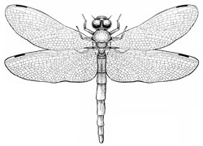 Odonata - dragonflies and damselflies

* long slender membranous wings with many cross-veins
* hind wings similar to forewings
* chewing mouthparts
* long, slender abdomen
* larvae are aquatic

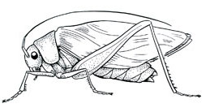

Orthoptera - grasshoppers, kaydids, and crickets

* forewings leathery and narrow
* chewing mouthparts
* many have hind legs modified for jumping

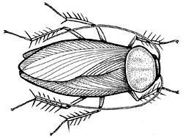

Blattaria - cockroaches

* forewings elongate, often thickened (leathery)
* chewing mouthparts
* running legs
* cerci
* long antennae

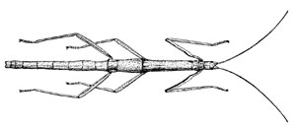

Phasmida - walkingsticks

* chewing mouthparts
* looks like a stick

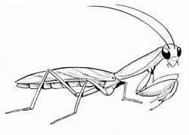

Mantodea - praying mantids

* forewings elongate, often thickened (leathery)
* chewing mouthparts
* enlarge forelegs for grasping prey
* distinctive neck

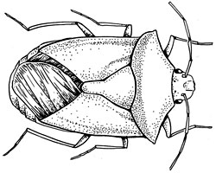Hemiptera - true bugs

* forewings thickened at base
* hind wings membranous
* piercing-sucking mouthparts

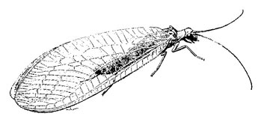 Neuroptera - lacewings, ant lions

* fore and back wings membranous with many veins
* chewing mouthparts
* antennae long and many segmented

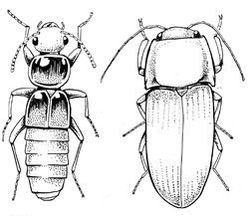

Coleoptera - beetles

* hardened forewing (elytra)
* hind wings membranous
* chewing mouthparts
* elytra meet in straight line down back

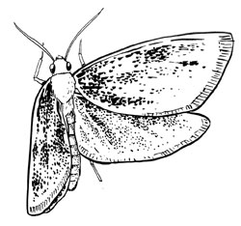

Lepidoptera - butterflies and moths

* fore and hind wings with scales
* antennae long and many segmented
* adults - siphoning mouthparts
* 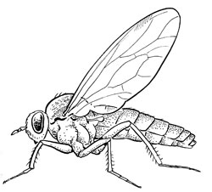larvae - chewing mouthparts

Diptera - flies and mosquitoes

* forewings membranous
* hind wings absent, replaced with balancing organs called halteres
* different types of mouthparts

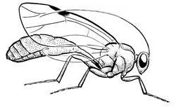

Hymenoptera - bees, wasps, and ants

* fore and hind wings membranous
* antennae usually threadlike
* chewing mouthparts with modification for sucking